Three ways to graph water-levels in a vernal pool in Eastham, MA, over a three-year period.
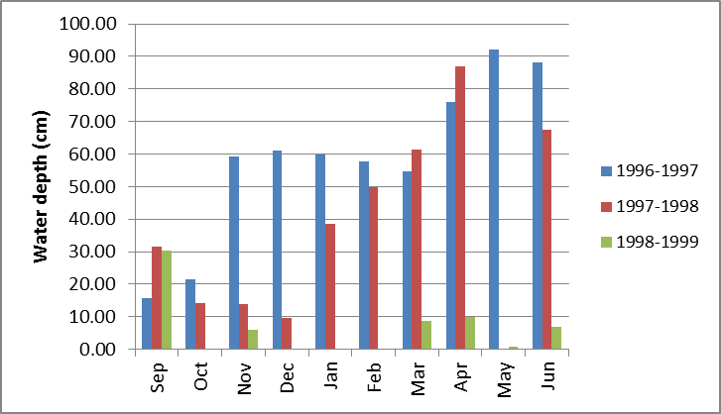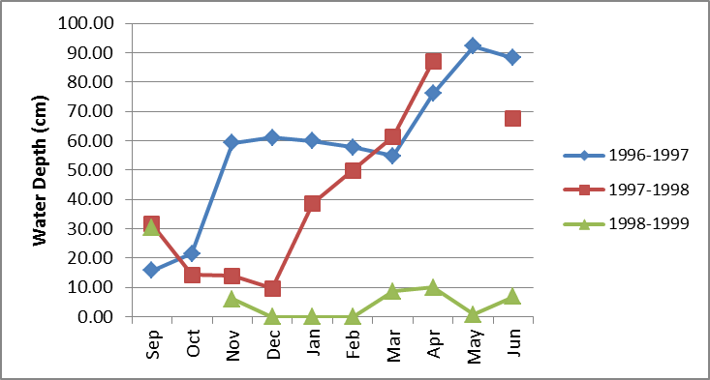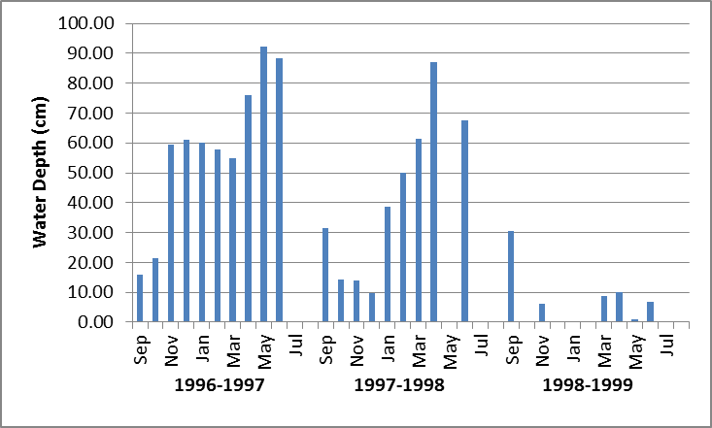

 |  | Year
 | 1996-1997 | 1997-1998 | 1998-1999
Sep | 15.75 | 31.60 | 30.38
Oct | 21.54 | 14.23
Nov | 59.33 | 13.92 | 6.00
Dec | 61.16 | 9.65 | 0.00
Jan | 59.94 | 38.61 | 0.00
Feb | 57.81 | 49.89 | 0.00
Mar | 54.76 | 61.47 | 8.74
Apr | 76.10 | 87.07 | 9.96
May | 92.25 |  | 0.82
Jun | 88.29 | 67.56 | 6.91

Note: No Data for July and August

Graphing Data
Bar Graph Showing Depth by Months for all three years
Line graph superimposing all three years (what are problems with this approach?)
Bar Graphs showing monthly variation for each year of study
Adjust axes, labels, gridlines, background, colors

Interpreting Results:
When is the pool typically filled to the greatest depth?
At what time of year is the water depth usually the lowest?
How much year-to-year variation occurs in annual maximum depth?
Do months differ in the amount of water-depth variation experienced between years?
What kinds of additional information might you want to look at to explain some of the differences observed?
How might the differences observed relate to biological processes in the pool, for plants and/or for animal life?

